 | 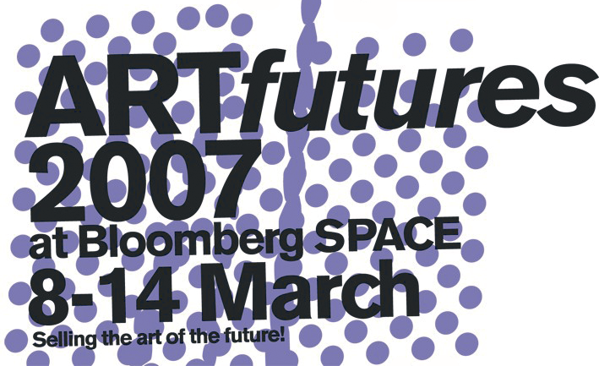 | 

COLLECTING THE ART OF THE FUTURE

An Insider’s View on Collecting Art by Emerging Artists
- Saturday, March 10th, 2007 -
Simmons & Simmons – City Point, One Ropemaker Street, London, EC2Y 9SS

Workshop package to include:
- A Invitation for two to the 2007 VIP event, the “Artists’ Party”
on Friday 9th March
- A copy of Owning Art: The Contemporary Art Collector’s Handbook
by Judith Greer and Louisa Buck
- A copy of New Art on View by Sheila McGregor
- Curated tour of ARTfutures

WORKSHOP PROGRAMME

- ---10.00-10.30am--- Coffee & Registration

- ---10.30-10.45am--- INTRODUCTION

- ---10.45-11.15--- ARTIST PRESENTATION
- Claude Heath

- ---11.15-12.15--- Panel (1): TALENT SPOTTING- The Search: How, When & Where?

- Jeni Walwin (Curator: CAS)
- David Risley (David Risley Gallery)
- Hugo Brown (Collector)

- ---12.15-12.45---ARTIST PRESENTATION
- Raul Ortega Ayala

.
- ---12:45-1:30--- Lunch

- ---1:30-2:30--- Panel(2): LOOKING TO THE FUTURE: Trends, Risks & Opportunities.
- Anders Petterson (ArtTactic)
- Alexander Branczik (Sotheby’s Contemporary Art specialist)
- Gallerist: Hollybush Gardens (Lisa Panting)
- Ceri Lewis (Curator)

- ---2:30.00-3.15--- Coffee + Visit to Simmons & Simmons Collection

- ---3.15-4.15--- Panel(3): CONTEMPORARY PATRONS: How to Become a Patron of Young Artists.

- Louisa Buck (Author, Journalist and 2005 Turner Prize judge)
- Anita Zabludowicz (Private collector)
- Stuart Evans (Simmons & Simmons Partner, and Curator of the Simmons & Simmons collection)
- Bob Lee (The Collective)

- ---4.30-5.30--- Curated Tour of ARTfutures+Champagne Reception

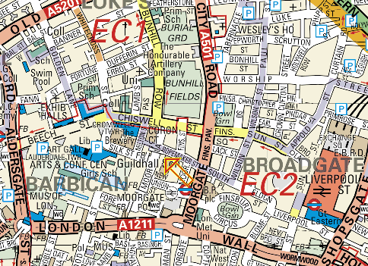

Simmons & Simmons
One Ropemaker Street

London, EC2Y 9SS

Media Partner:


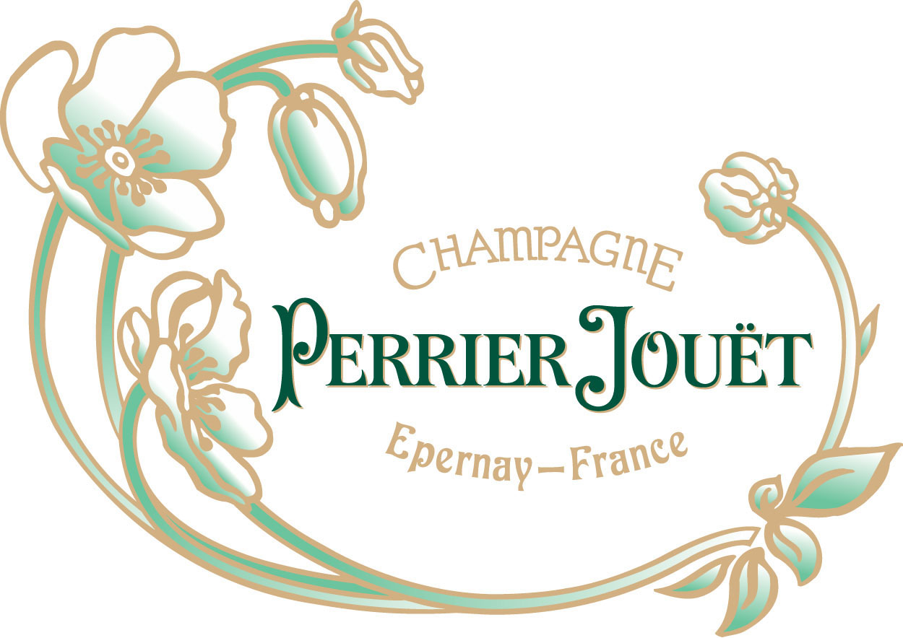 |  | 